Link Github
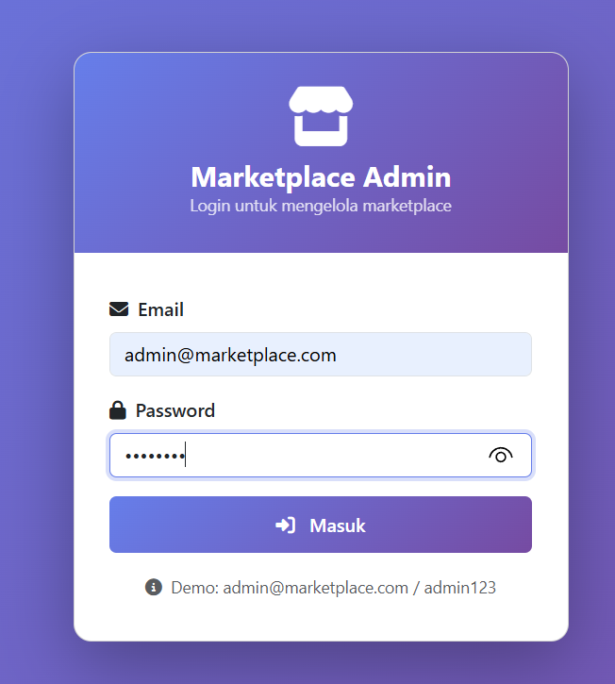
https://github.com/Hidayat808/security/tree/7067697e79813c83433e30e5a337d10a86cd4986/UJIKOM
Gambar Implementasi
Login Admin

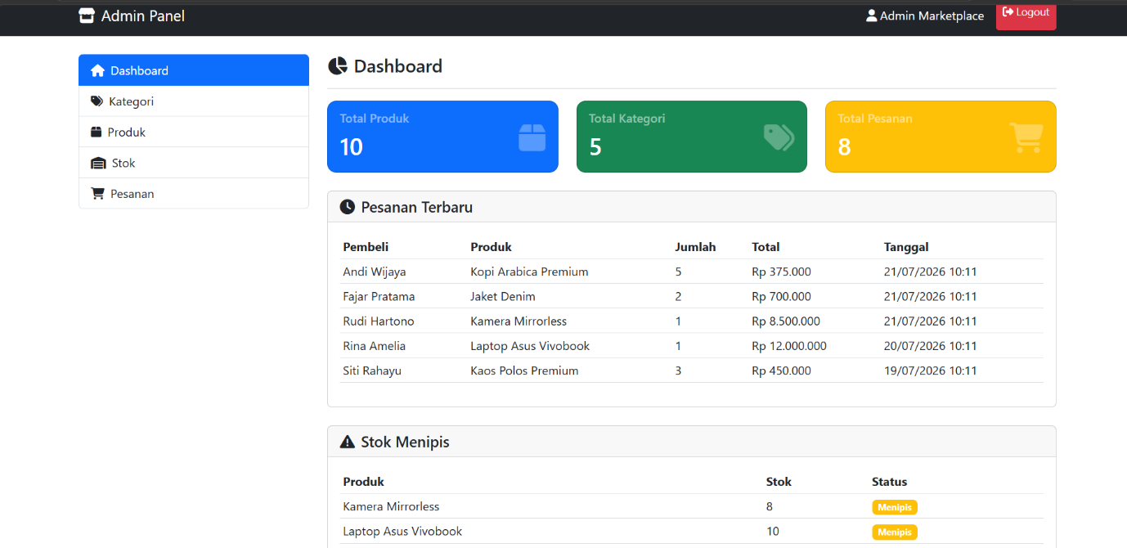
Tampilan dashboard admin panel

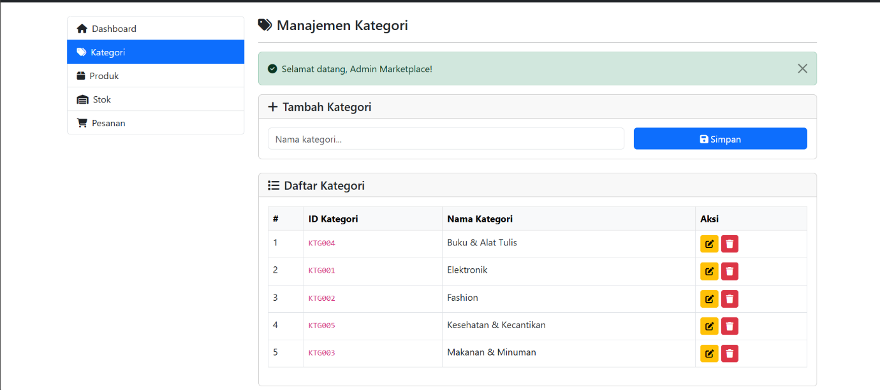
Tampilan Kategori

Tampilan Produk
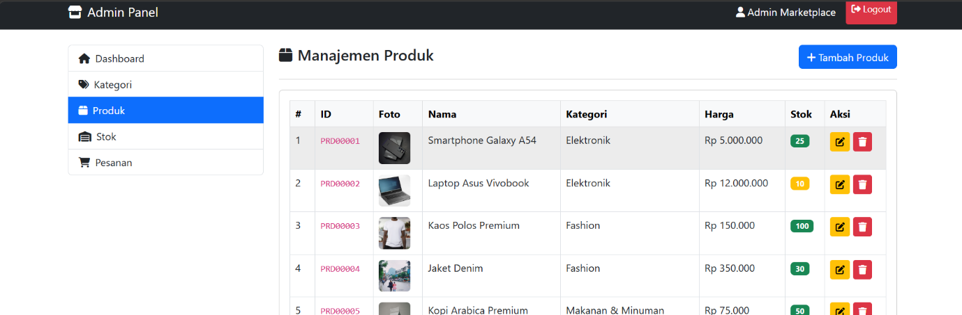
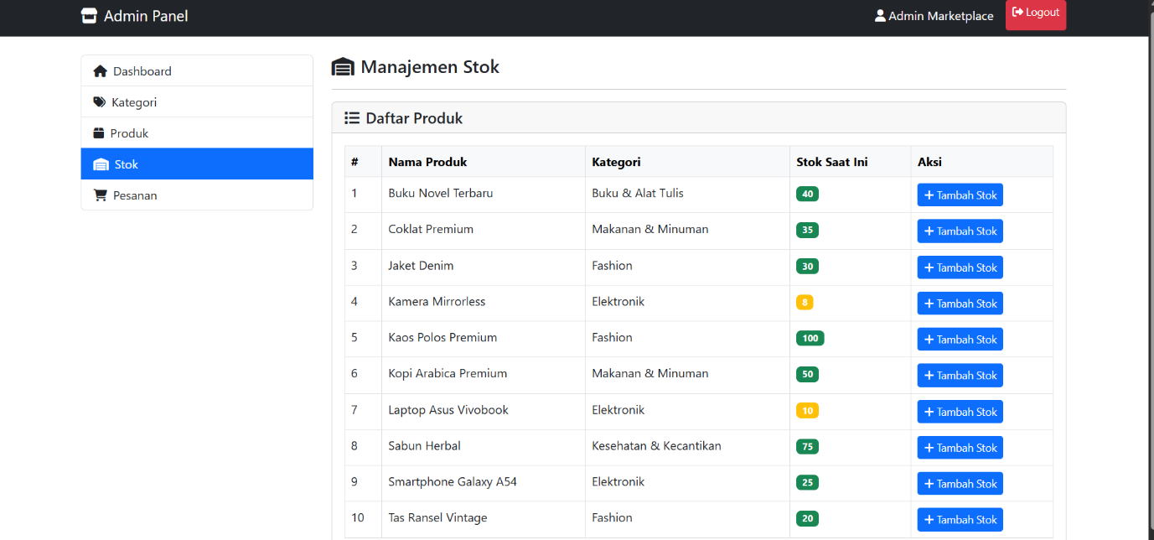
Tampilan Stok

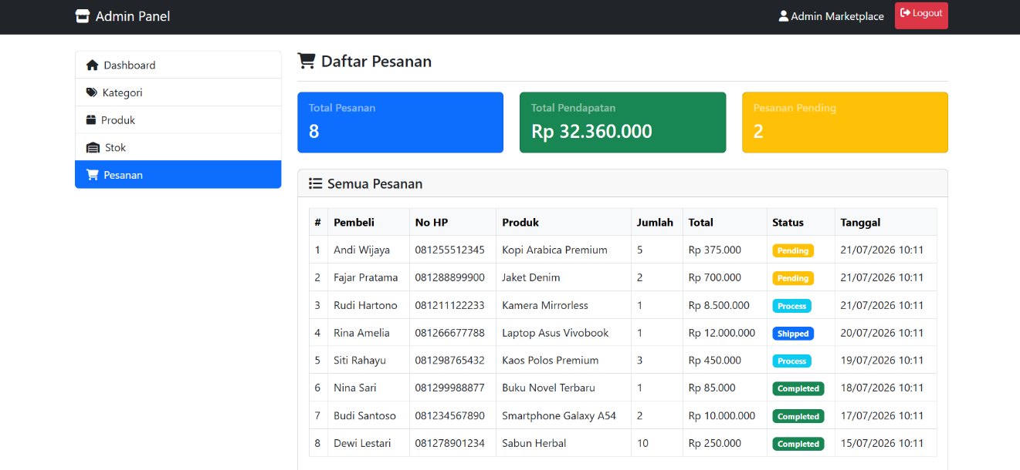
Tampilan Pesanan

Tampilan dashboard pembeli
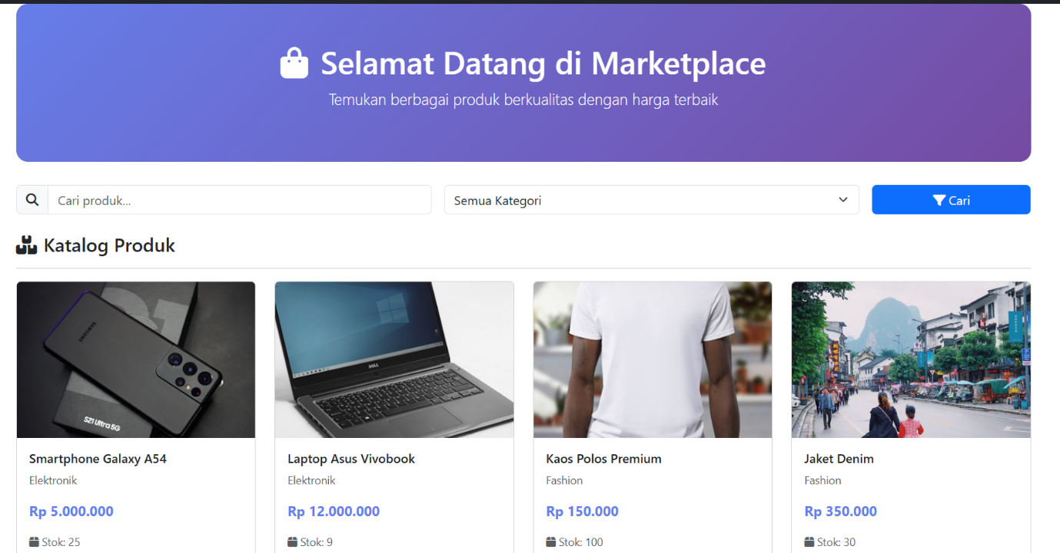

Tampilan Pesan barang
